# IBM Business Process Manager Analytics

**Introduction**

The key value of IBM Business Process Manager (BPM) is in streamlining custom enterprise business processes to better optimize service and cost. It does this namely through 1) custom process applications to manage work, and 2) process analytics for workers, managers, and analysts to assist their decision making in the execution and management of work and the design of processes. This technology demonstration aims to enhance BPM capabilities for (2) process analytics, with modern technologies which can excel in the era of big data and analytics, taking advantage of the full potential of the rich information into business operations afforded by custom process apps executing in BPM.

The BPM Analytics aims to enhance BPM for two scenarios: 1) BPM Analytics - providing enhanced process analytics features directly within the BPM offering targeting BPM user roles, and 2) 3rd Party Analytics - providing enhanced features to publish process data to external data and analytics solutions provided by IBM, customers, and partners.

This demonstration enhances the existing BPM Dynamic Event Framework (DEF) solution to publish business events in JSON message format, after a serial of the reformat and aggregation, store the query-optimized documents at the Elasticsearch, then finally the documents can be fed in the dashboard at the Kibana.

**Elasticsearch**

Elasticsearch, built on top of Apache Lucene, is a search engine with focus on near real-time analysis of the data, and is based on the RESTful architecture. It provides standard full text search functionality and powerful search based on query. Elasticsearch is document-oriented/based and we can store everything we want as JSON. This makes it powerful, simple and flexible.

**Logstash**

Logstash is a tool for managing events and logs. We can use it to collect logs, parse them, and store them for later use. In ELK Stack logstash plays an important role in shipping the log and indexing them later which can be supplied to Elastic Search.

Logstash is the part of the ELK stack responsible for collection, transformation and shipping of the pointed log files from remote sources or by listening to records on specific ports . It can be configured to receive records from a variety of sources including flat files, TCP ports or local system out logs ( our case) . The paths are typically defined in input.conf files . Once the source data is collected the filter configuration files transforms and enriches the log data. Finally based on the output configuration file a specific method of Elasticsearch sends the log records to Elasticsearch database for indexing.

**Kibana**

Kibana is a user-friendly way to view, search and visualize our log data, which will present the data stored from Logstash into Elasticsearch, in a very customizable interface with histogram and other panels which provides real-time analysis and search of data that we have parsed into Elasticsearch.

**How Do They Work Together?**

Logstash is essentially a pipelining tool. In a basic, centralized installation a logstash agent, known as the shipper, will read input from one to many input sources and output that text wrapped in a JSON message to a broker. Typically, Redis, the broker, caches the messages until another logstash agent, known as the collector, picks them up, and sends them to another output. In the common example, this output is Elasticsearch, where the messages will be indexed and stored for searching. The Elasticsearch store is accessed via the Kibana web application which allows you to visualize and search through the logs. The entire system is scalable. Many different shippers may be running on many different hosts, watching log files and shipping the messages off to a cluster of brokers. Then many collectors can be reading those messages and writing them to an Elasticsearch cluster.



Creating your first dashboard

By default, IBM BPM Analytics provides the Process Performance, Task, and Team Performance dashboards. If you have KPI or business data that you want to be tracked in a dashboard, you must define your own dashboard in Kibana.

Enabling tracked fields

When you define process variables in Process Designer, you can enable the **Track this Field** option. If you select this option, the field is recorded as autotracking.

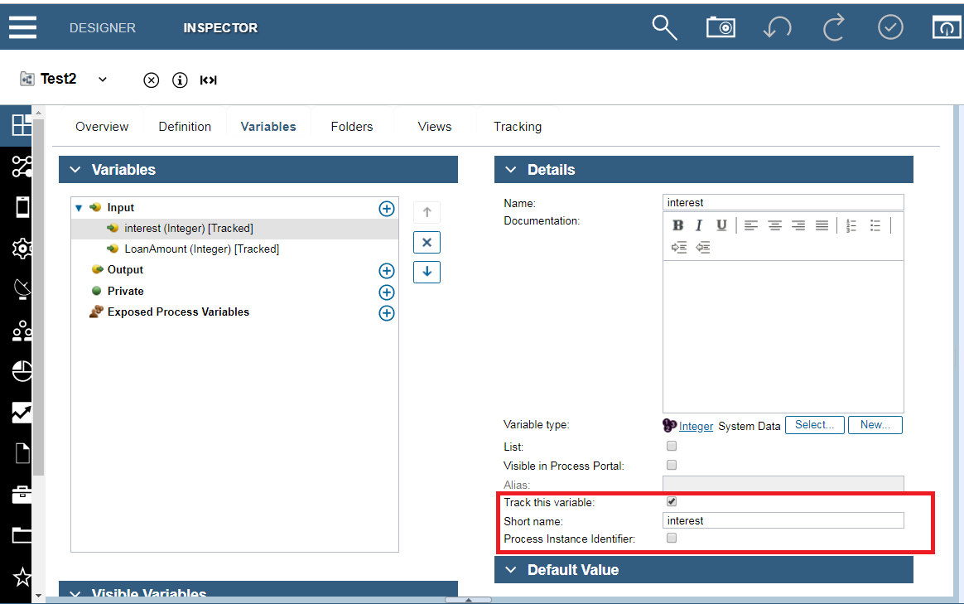

In this example of a Test2, the autotracked fields include: loanAmount and interest. The autotracking group name is Loan_Details.

**Note**: For the tracked field and its value to be attached to the DEF event, the **Enable Autotracking** option must be selected in the Tracking Groups panel.

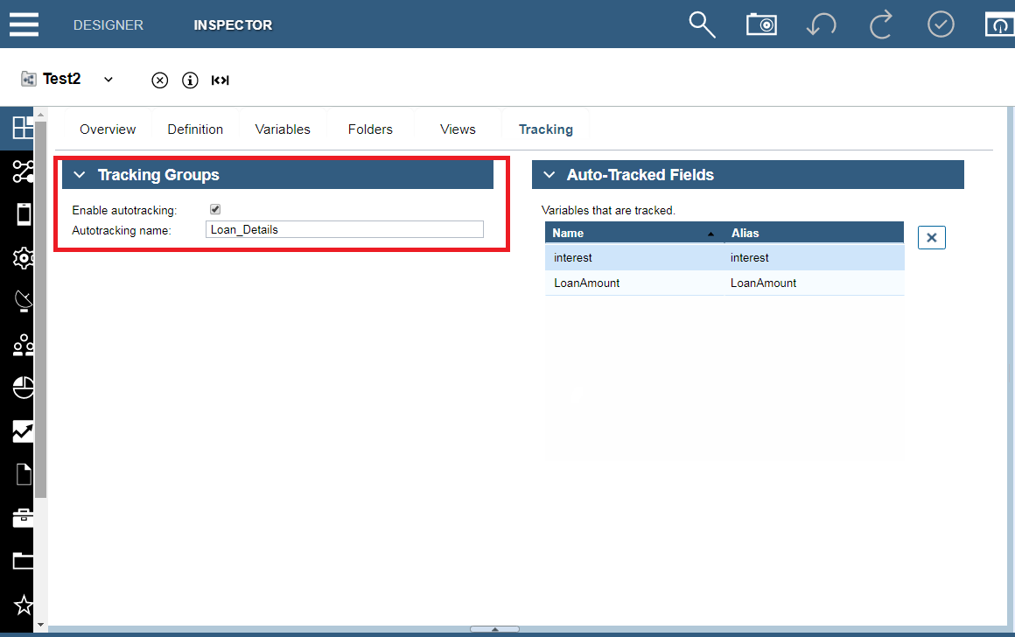

By using the ProcessSummary type, you can find the mergedTrackedFields setting from the JSON document. This document contains the business data you tracked.

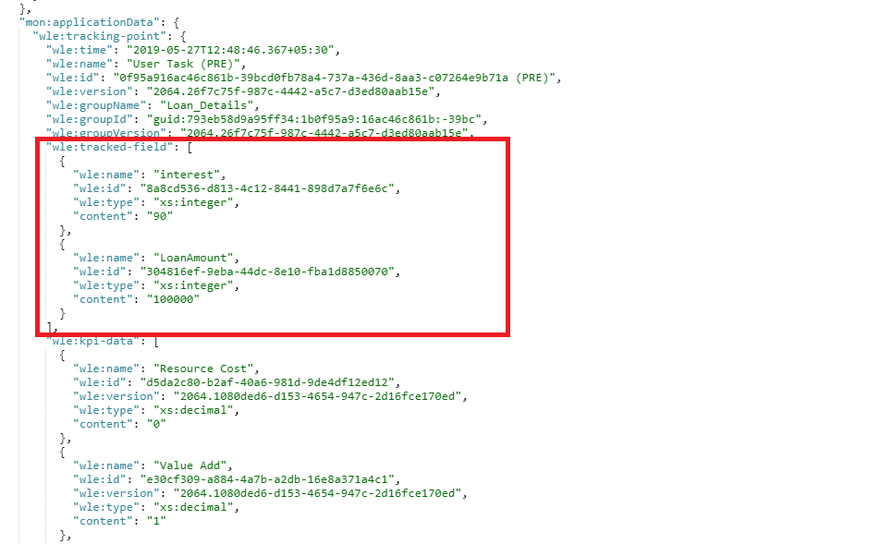

Creating the dashboard in Kibana

Based on the business data from the previous step, you can create a pie chart. The dimension is the region, the matrix is the sum of the loan amount, and the result is for this month.

Refreshing the index field list

To refresh the index field list in Kibana, select **Management->Index Patterns->monitor->  (Refresh field list)**

Creating a visualization

From the Visualize panel, select **Pie chart**. If you do not have a predefined saved search, select the monitor index at **From a New Search, Select Index** section.

From the metrics section, for the aggregation logic, select **Sum** and the Field is trackedFields.loanAmount.integer. In **buckets**, select the aggregation by **Terms** and Fields is trackedFields.interest.integer. For the other fields, you can use the default values. After you click  (Run), you can review the chart on the right side.

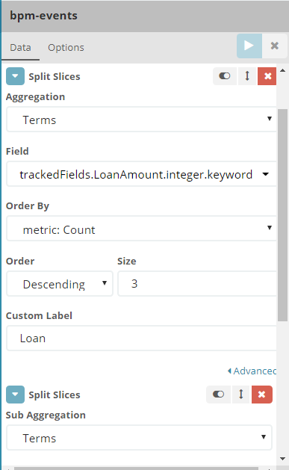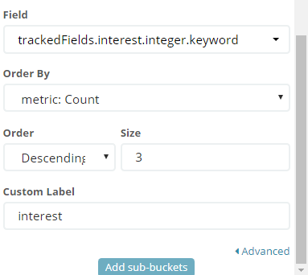

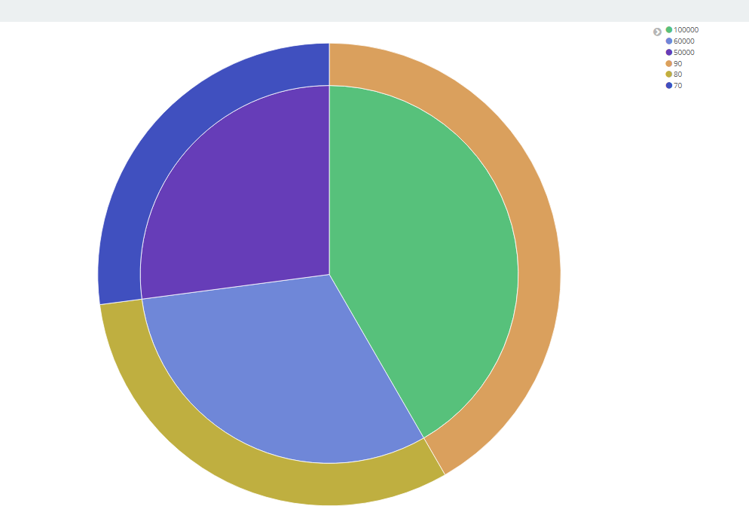

Saving the visualization

After you are finished defining the visualization, you can save it. In this example, it is saved as my first pie chart.

Adding the visualization to the dashboard

Select **Dashboard->new->add** to create a new dashboard. The wizard guides you to select the existing visualization. To find the example, enter my in the Search field. When Kibana provides the available options, select my first pie chart to add the visualization to the dashboard.

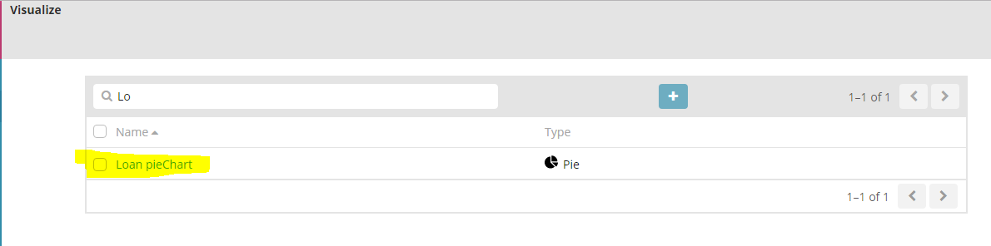

Saving the dashboard

When you are finished, you can save the dashboard. In this example, it is saved as Loan pieChart.

* **Search logs data using Syntax:**

The search provides an easy and powerful way to select a specific subset of log messages. The search syntax is pretty self-explanatory, and allows boolean operators, wildcards, and field filtering. For example, if you want to find "Loan_Details" tracking group name that were generated previously .You could also search like trackingGroupName:Loan_Details And processApplicationName:HarishTest or any other data that is contained in your logs.

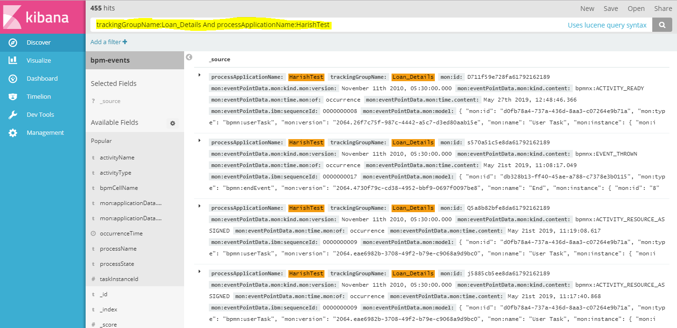

* **View logs data in the form of tables**

You can also view the logs data in the form of table in the Discover section select the fields that you want to see in the form of table format. You can also remove the fields if not required.

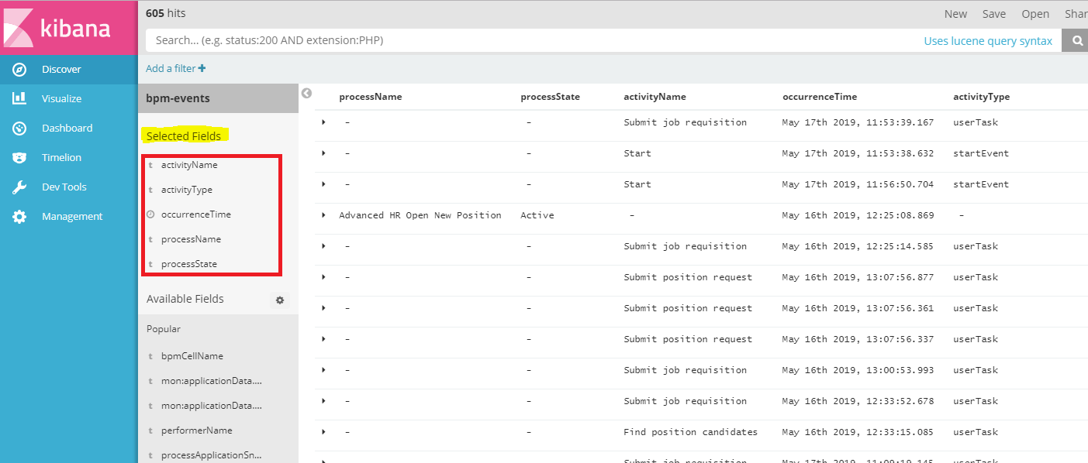

You can able to view the data in the form of Json format also by clicking on JSON icon.

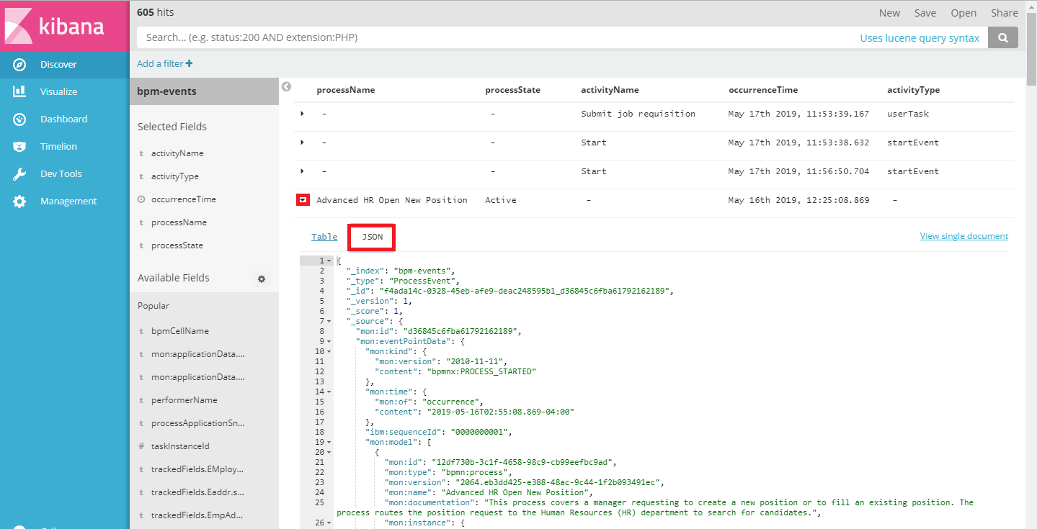

* **Team Performance:**

We can find task assigned to each team and team members.

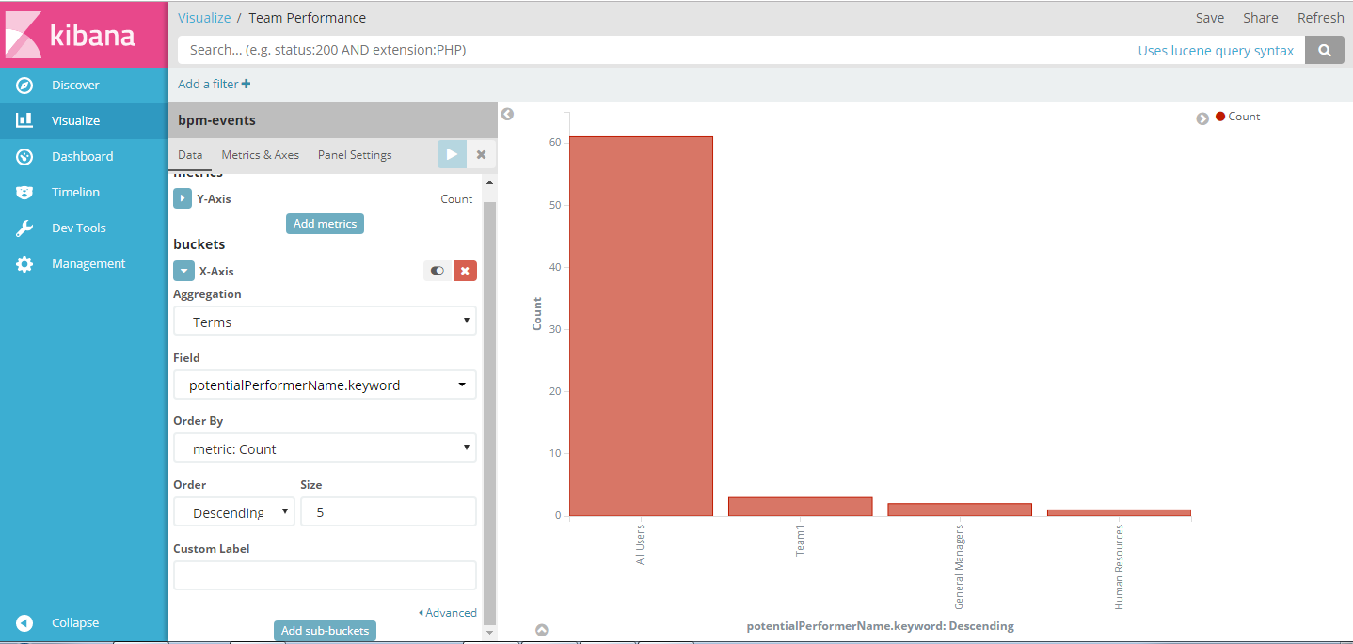

* **create any type of visualization:**

The Kibana Visualize page is where you can create, modify, and view your own custom visualizations. There are several different types of visualizations, ranging from Vertical bar and Piecharts to Tile maps (for displaying data on a map) and Data tables. Visualizations can also be shared with other users who have access to your Kibana instance.

If this is your first time using Kibana visualizations, you must reload your field list before proceeding. Instructions to do this are covered in the **Reload Field Data** subsection, under the [Kibana Settings](https://www.digitalocean.com/community/tutorials/how-to-use-kibana-dashboards-and-visualizations#kibana-settings) section.

### Create Vertical Bar Chart

To create a visualization, first, click the **Visualize** menu item.

Decide which type of visualization you want, and select it.

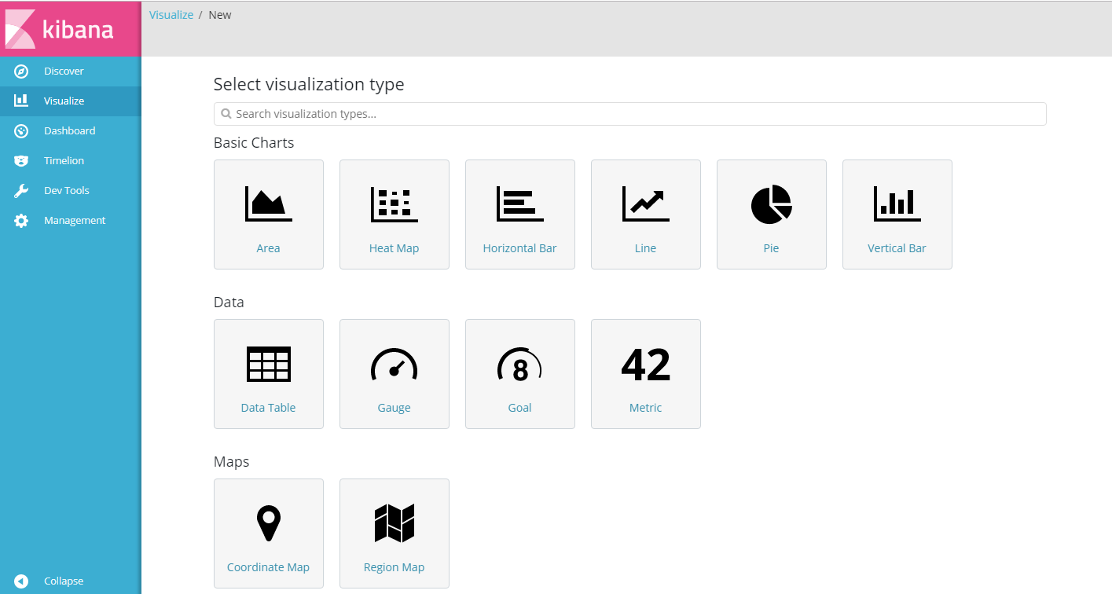

* **create dash boards for your visualizations:**

The Kibana Dashboard page is where you can create, modify, and view your own custom dashboards. With a dashboard, you can combine multiple visualizations onto a single page, then filter them by providing a search query or by selecting filters by clicking elements in the visualization. Dashboards are useful for when you want to get an overview of your logs, and make correlations among various visualizations and logs.

### Create Dashboard

To create a Kibana dashboard, first, click the **Dashboard** menu item.

If you haven't created a dashboard before, you will see a mostly blank page that says "Ready to get started?". If you don't see this screen (i.e. there are already visualizations on the dashboard), press the **New Dashboard icon** (to the right of the search bar) to get there.

